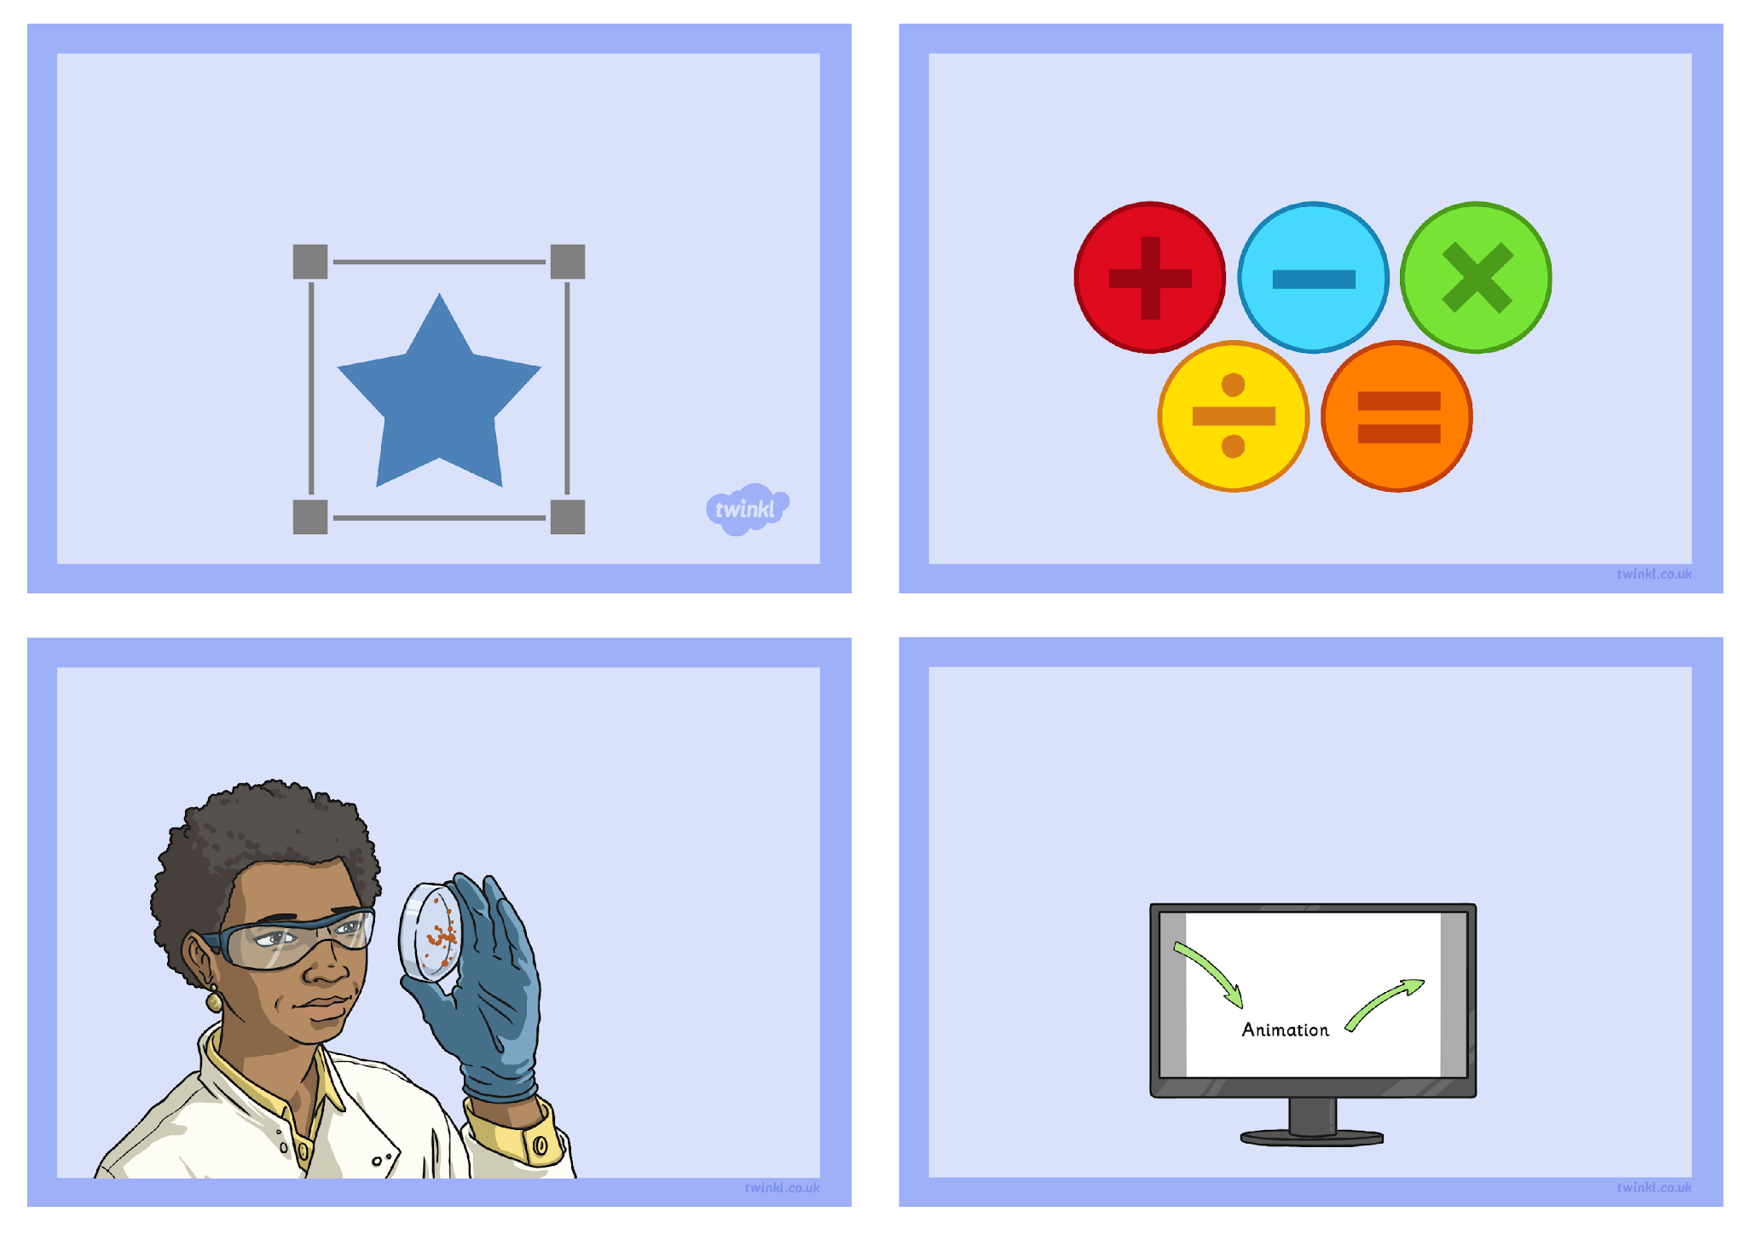
Action Settings
Challenge Cards
Create a maths quiz using action settings.
Create a science quiz using action settings.
Investigate the other action settings and think about how they might be used.
Create a presentation about some learning in class that uses different action settings.
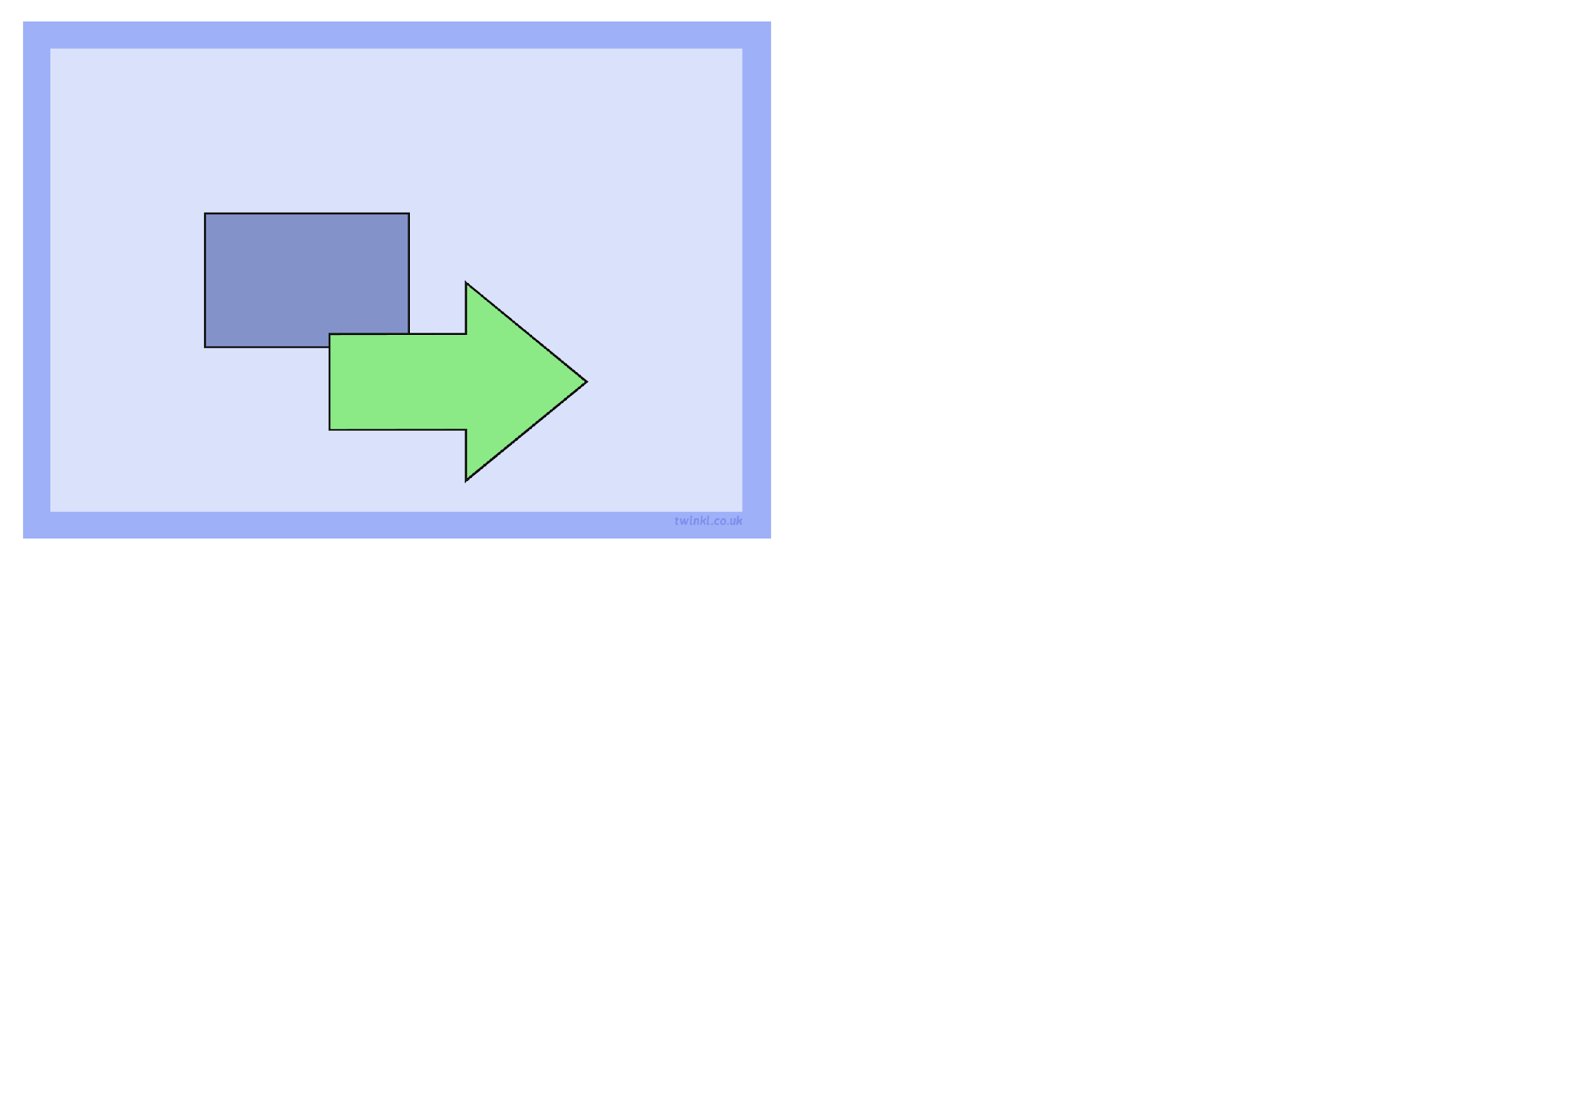
Make a presentation slide. Add some shape buttons and create sound actions for each button. Label each button with a relevant word.

